

Joanna Project Leeds
Impact Report 2025



Table of Contents

- Welcome – Reflecting on 20 years of hope and sanctuary
- Who We Are – Our strategic role in the Leeds community
- Vision, Mission, and Values – The heart of our journey
- Our Staffing Team – Professional leadership and strategic shifts in 2025
- Our Trustees – Personal governance and a year of transition
- Our Volunteers: The Heart of the Project – Celebrating our connections
- In Their Own Words – Testimonials from our women
- A Journey of Recovery – A powerful 7-year success story
- Our Weekly Activities – A week at Joanna House and on the streets
- Partner Spotlight: Collaborative Care – Removing barriers with on-site specialists
- What We Have Achieved: 2025 Statistics – Our impact in numbers
- Special Events & Milestones – A month-by-month timeline of our year
- Looking to the Future – Strategic goals for prison work and housing
- Stay Informed & Support Us – How you can be involved in our future
- Contact Us – Our details

1. Welcome
Welcome to our 2025 Impact Report. Following on from our 20th Anniversary in 2024, this year has been one of significant change as we have welcomed new staff members to the team including a new Director and Chair of Trustees. As we reflect on the past year, we remain deeply committed to holding the brokenness of those we serve, ensuring that no woman is ever “forgotten”. This report celebrates the courage of our women, the dedication of the staff and volunteer teams and the wider support of the Joanna community, all of which make this vital work possible.

2. Who We Are

The Joanna Project’s Christian identity is expressed through love in action, hope in adversity, and a commitment to dignity for every woman. It shapes our ethos without excluding those who do not share our faith. Together, Christian and non-Christian, we create a community of care that reflects the heart of our mission: to walk alongside women with compassion, respect, and an unwavering belief in their worth.

We are a recognised and respected organisation working at the heart of the community. We are defined by our Christian faith and our strong collaborative relationships, working tirelessly with Leeds City Council, the local policing team, charities, healthcare providers and statutory bodies, to create a holistic and personalised network of care for the women that we support.

We also maintain vital links with the universities in Leeds and beyond, ensuring our work both contributes to and learns from the latest research and best practices in trauma-informed care.

Situated in a community ranked within the top 10% most deprived areas in the country, our “homely and beautiful” sanctuary at Joanna House provides a vital anchor. Here, we deliver tailored, trauma-informed support to women facing multiple disadvantages, street-based sex work, and life-controlling addictions—offering radical acceptance where it is needed most.

3. Our Vision, Mission, and Values

- Vision: We believe all women should live healthy, whole lives, free from exploitation, abuse, addiction, and poverty, exercising choice and enjoying hope for the future.
- Mission: To actively reach out and journey with women involved in, or at risk of, street-based sex work in Leeds. We work holistically to build confidence, increase safety, and raise self-esteem.
- Core Values:
  - HOPE: We are aspirational for change and committed to a lifelong journey.
  - LOVE: We offer relational, non-transactional support and radical acceptance.
  - DIGNITY: We champion the dignity of choice and provide creative, holistic help for body, mind, and spirit.

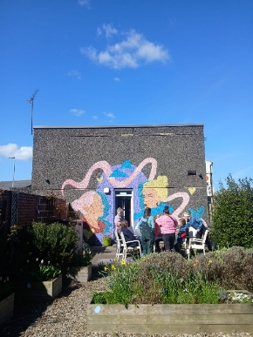


Cake to celebrate one of our women’s birthdays
Easter celebrations at Joanna House

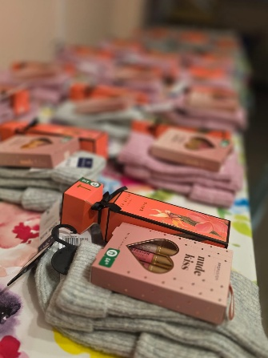
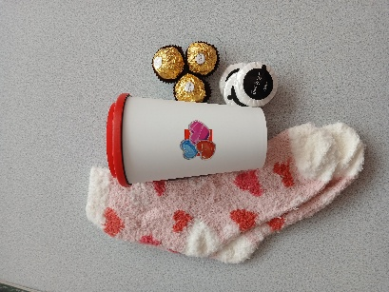

Christmas gifts for our women
Valentine’s gifts for our women
4. Our Staffing Team

The Joanna Project is powered by a dedicated team of six staff members equating to 4.6 FTE (full time equivalent). These staff members are the professional and strategic backbone for our frontline operations. Every role is designed to ensure that our trauma-informed care is safe, effective, and sustainable.
- Director & Safeguarding Lead
Our new Director, Sarah, started in March 2025 and is responsible for the strategic growth of the project. Sarah is the central point of contact for all safeguarding concerns and focuses on developing new and existing relationships across the city and influencing policy to ensure the voices of our women are heard at every level.
- Outreach and Support Manager (new for 2025)
Ellen took on the new role of Outreach and Support Manager towards the end of the year and now oversees the day-to-day activities of Joanna House and manages our service capacity to meet the ongoing needs of our women. As the Outreach Lead, Ellen also coordinates our daytime and nighttime operations and ensures all frontline activity is safely governed.
- Outreach and Support Workers (x3)
Ros, Laura and Rachel form our dedicated frontline team providing daily one-to-one support, advocacy, and expert advice. They are the first responders to women in crisis, offering immediate help and long-term journeying to ensure every woman has a path to safety. Rachel started in April and was a welcome addition to the team.
- Office Manager
The engine behind our operations, Emanuela is responsible for managing the charity’s finances, reporting on budgets, and ensuring the organisational health of the project so that our frontline staff can remain focused on the women.

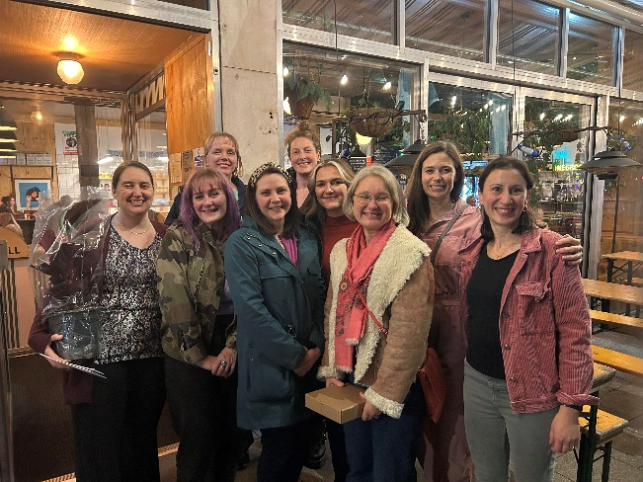
Joanna Project staff team, in 2025
5. Our Trustees

The Joanna Project is governed by a dedicated Board of 6 Trustees who provide their time and expertise on a voluntary basis. They bring a wealth of professional experience to the project, with backgrounds in front-line work, HR, Finance, Safeguarding, volunteering, and Support Work.
This personal and professional diverse mix ensures that every penny that the project receives is managed with transparency. Above all, our Trustees are committed to our Christian ethos, ensuring that the values of Hope, Love, and Dignity permeate every level of the organisation.
A Year of Transition:
In 2025, we marked a significant change in our board leadership. Our Chair of Trustees, Angharad, stepped down after dedicated years of service in this role. We are deeply grateful for her guidance and commitment to our mission. We are delighted to welcome Heather to the helm as our new Chair. As an experienced volunteer and Trustee at Joanna Project, Heather brings a wealth of project knowledge, and we look forward to working with her through 2026 and beyond.

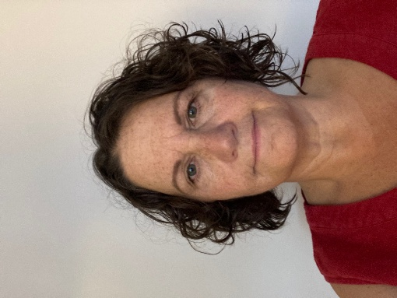
Heather, our new chair of trustees

5. Our Volunteers: The Heart of the Project

Our team of approximately 20 dedicated volunteers are the lifeblood of our daily work. In 2025, they contributed a staggering 800 hours—an average of 17 hours every week—across outreach, baking, admin, lunchtime support and house care.

Celebrating Our Team:
To honour this incredible commitment, in the summer of 2025, we hosted a Volunteer Celebration BBQ in the Joanna Garden. It was a wonderful evening where burgers were eaten, games were played, and stories were shared. Moments like these allow us to pause and thank the individuals who make our "homely and caring" atmosphere possible through their selfless service.

6. In Their Own Words

At the heart of everything that we do are the women that we serve and 2025 brought moments of sadness, challenge and joy in equal measure. Here are just a handful of those moments…
"You guys are like a family to me, seriously, it means everything."

"You helped me when no one else would."

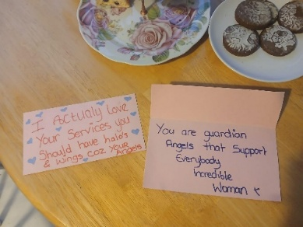
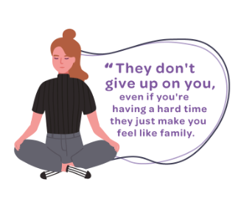
“I’m 90 days clean!”
Messages from our women

7. A Journey of Recovery: A 7-Year Reflection

"I am one of the ladies that the Joanna Project supported and helped. Jackie was amazing and she showed me compassion and love ❤️ I will never forget her. Your women fed me when I was hungry, clothed me when I was cold. I will never forget all that you did for me. I’m happy to say that I am now in recovery and nearly 7 years away from my old life. But I still pray for the women that are out there, I still hold a space for them 🙏. Keep up the amazing work ladies."

8. Our Weekly Activities: A Week at Joanna House
- Daytime Sanctuary: Open Mon–Thurs (9:30 am – 5:00 pm) and Fri (9:30 am – 4:30 pm). Women can access support for both practical and emotional needs, including laundry and hot baths.
- Tuesday Drop-In (12:00 pm – 3:00 pm): Focused on our 'family' lunch (served approx. 12:30 pm), social support, crafts, discussion groups, and community days out.
- Thursday Drop-In (12:00 pm – 3:00 pm): Focused on practical support with partners: Forward Leeds, Leeds Sexual Health, Bevan Healthcare, DWP, and pastoral care from the Salvation Army.
- Evening Outreach: Tuesday and Thursday (8:30 pm – 11:30 pm). Providing safety, emotional support, hot drinks, and snacks on the streets of Leeds.

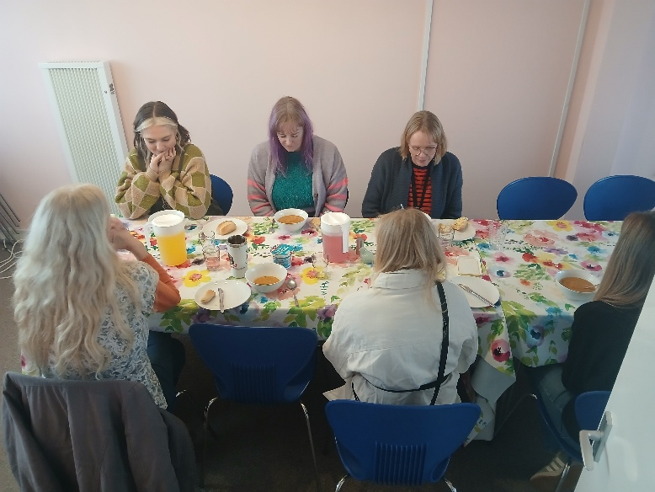
Family lunch at our Tuesday drop- in

10. Partner Spotlight: Collaborative Care
By hosting partners directly at Joanna House, we remove the barriers that prevent our women from accessing help:

- Bevan Healthcare & Leeds Sexual Health: Clinical staff on-site for primary care and screenings.
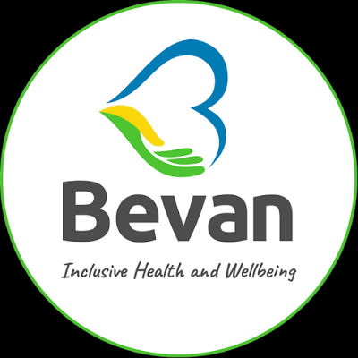

- Forward Leeds: Direct links for alcohol and drug recovery support.

- DWP: On-site advisors to demystify benefits and ensure financial entitlements.


- The Salvation Army: Providing essential pastoral care and spiritual strength


9. What We Have Achieved: 2025 Statistics

9. Special Events & Milestones
In addition to regular collaboration meetings, staff development, and rigorous reviews, we celebrated these 2025 highlights:
Month | Milestone | Activity Description
January | New Team Member | Emanuela joined the project as our new Office and Finance Manager, bringing vital expertise to our core operations.
February | Valentine's Care | Distribution of Valentine's gifts for our wonderful women, ensuring they felt loved and valued.
March | Leadership Milestone | Sarah, our new Project Director, officially started her role to lead our next chapter of strategic growth.
April | Growth & Care | Easter Egg Distribution for all our women, and the successful recruitment of a new team member to increase outreach and support capacity.
May | Wellness Trip | Splash-tastic Trip: Seven women joined us for a day of joy and wellness at an indoor water park.
June | Volunteer Celebration | Hosted a BBQ in the Joanna Garden to celebrate our 20+ wonderful volunteers and their 800+ hours of service.
July | New Provision | Discovery Group Launch: A new peer-support initiative designed to help our women explore new interests and build confidence.
August | Ongoing Advocacy | Sustained support month focusing on intense housing advocacy during the peak summer period.
September | City-Wide Action | Participation in the Leeds Women’s Homelessness Census to ensure the needs of our women are represented in city policy.
October | Building & Appeals | House Maintenance Day to care for Joanna House, and the official launch of our Annual Christmas Appeal.
November | Networking & Prep | Attended the annual VCSE Conference in Bradford and began the collation of Christmas gifts for our women.
December | Festive Community | Christmas Present Wrapping Days, a lunch for 20+ guests, and our Women's Christmas Party at The Barn Cafe in Meanwood.
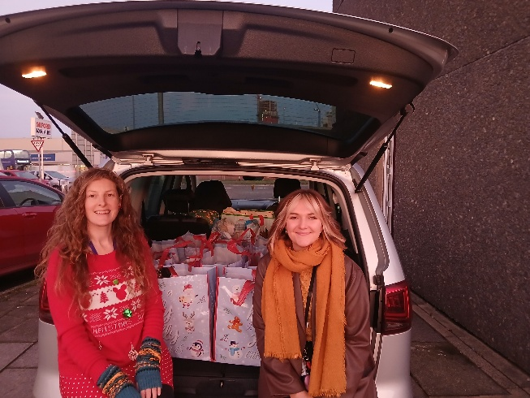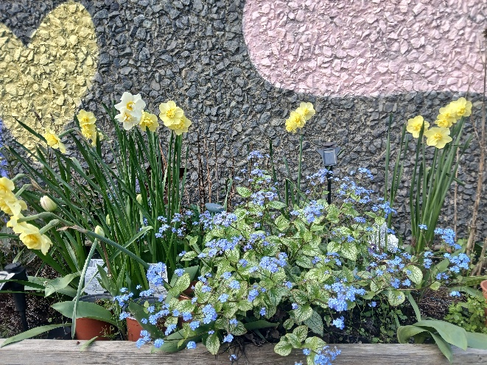
Joanna Project sanctuary garden
Our support workers ready to deliver Christmas presents to the women

11. Looking to the Future: Strategic Growth

- Prison Work & Resettlement: We want to rekindle our visibility in prisons, providing tailored 1:1 support for women enabling greater support as they exit custody to help break the cycle of reoffending.
- Intense Housing Support: Expanding capacity to help women navigate the move from "hidden homelessness" to secure, permanent homes.
- Daytime-Focused Outreach: Adapting to reach women active during the day as sex work patterns shift.
- Cost of Living Crisis: Strengthening our response to the financial pressures forcing women into sex work just to pay basic bills.
- Recovery & Church Connection: Deepening links with rehab services and local church communities to offer a long-term sense of belonging.

12. Stay Informed & Support Us

The Joanna Project is a community-driven charity, and your ongoing engagement is what allows us to keep our doors open. There are three primary ways you can stay connected and support our journey:

Maximise Your Impact with Gift Aid
If you are a UK taxpayer, you can make your donation go 25% further at no extra cost to you. By simply ticking the Gift Aid box when you donate, the government will add 25p to every £1 you give. This means a £20 donation becomes £25, allowing us to provide even more meals and advocacy sessions.
The Power of Your Donation
- £2.38: Feeds one woman a high-quality, hot "family" lunch at our drop-in.
- £15.00: Provides a "Welcome Pack" of essential toiletries and clean clothes.
- £50.00: Funds a dedicated 1:1 advocacy session to help a woman secure emergency housing.

Prayer Support: Our 'Secret Angels'
Our work is underpinned by a faithful network of "Secret Angels" who commit to praying for the women we serve and the safety of our outreach teams. If you would like to receive our monthly prayer points, please email us at the address below.
Charity No: 1138640

